# PC Based Software

## User Interface

As a method to set the time and alarm on the clock, wireless PC communication will be employed. This method has been selected due to its convenience since most users of the clock will own or have access to a PC as opposed to an iPhone or Android device. To utilise the PC functions, a simple user interface has been designed. At this early stage, the user interface will allow users to set the time and set the alarm wirelessly. Should time allow, extra features will be added such as a calendar and weather system.

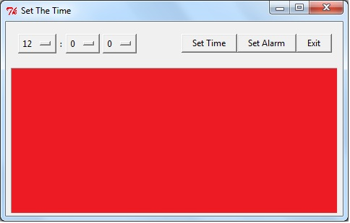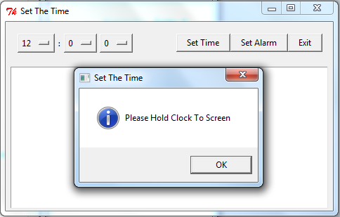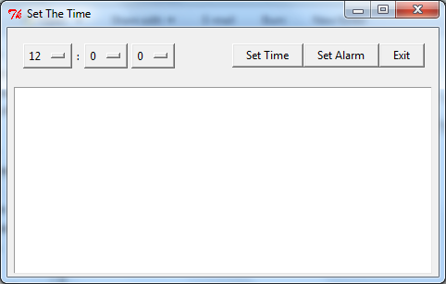Figure 1 illustrates the basic design intended for the user interface. To set the time, the user clicks on the dropdown menus on the top left and selects a desirable time. Once a time has been selected, the user can then select whether they desire to set the time or set the alarm. After an option has been selected, a message box will appear asking the user to hold the clock up to the screen as shown in Figure 2. The large white canvas will subsequently flash several lights and colours to transmit the time to the clock, illustrated in Figure 3. The exact method of this transmission will be explained in a later section.

*Figure 3: Canvas Flashing to Transmit Time to Clock*

*Figure 2: Message Box Instructing User to Hold Clock Up to Screen*

*Figure 1: A Primitive Version of the Proposed User Interface*

## Optical Interface

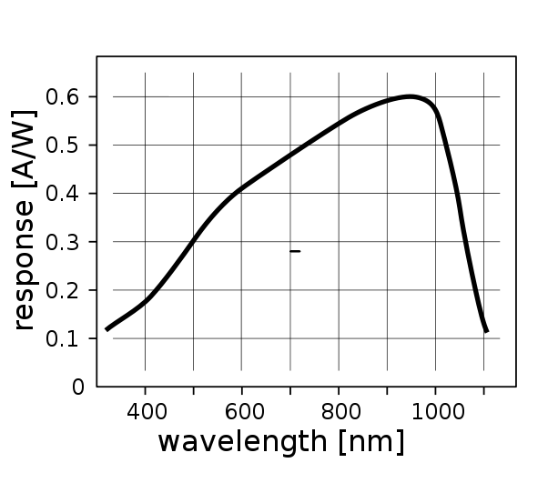In order to send information to the clock via PC, a visible light optical interface will be utilised. The general idea is that the PC will flash a set of lights that the clock reads and information and subsequently executes the commands. A photodiode will be used to interpret the information received.

Figure 1 illustrates how the photodiode will respond depending on the wavelength of the visible light being received with the response being measure in Amps/Watts. As shown, there is a major difference between red light (620–750 nm) and blue light (450–495 nm). Hence it is proposed that a set of red lights will flash and will be bookmarked by blue lights, depending on the information being sent. The microcontroller will then process the responses received from the photodiode and executed the received commands. This concept is still in its infancy and may be changed as a result of consultation with the tutors or the lecturer.

*Figure 4: The Wavelength of the Received Light against the Response of the Photodiode*

Figure 5 is a basic flowchart illustrating the process of the transmission of data.

*Figure 5: A flowchart detailing the transmission process*

The microcontroller interprets the response from the photodiode and executes commands.

The photodiode on the clock receives the lights.

The lights are displayed rapidly on the screen

User inputs desired data into the user interface.

Interface converts the data into a meaningful set of lights